**International Institute of Professional Studies**

**Devi Ahilya Vishwavidyalaya**

**Indore, MP, INDIA  
2015**

Software Project Management Plan

**TABLE OF CONTENTS**

**1. Introduction**

1.1 Project Overview

1.1.1 Purpose, Scope and Objective  
 1.2 Project Deliverables   
 1.3 Evolution of the SPMP  
 1.4 Reference Materials   
 1.5 Definitions and Acronyms

**2. Project Organization**

2.1 Process Model   
 2.2 Organizational Structure   
 2.3 Project Roles and Responsibilities  
 2.4 Organizational Interfaces

**3. Managerial Process**

3.1 Management Objectives and Priorities   
 3.2 Assumptions, Dependencies, and Constraints   
 3.3 Risk Management   
 3.4 Monitoring and Controlling Mechanisms   
 3.5 Staffing Approach

**4. Technical Process**

4.1 Methods, Tools, and Techniques   
 4.2 Software Documentation   
 4.3 Project Support Functions

**5. Work Packages, Schedule, and Budget**

5.1 Work Packages   
 5.2 Resource Requirements

5.2.1 Resource control plan

5.2.2 Quality control plan

**1.  INTRODUCTION:**

This section gives a scope description and overview of everything included in this

SRS document. Also, the purpose for this document is described and a list of

abbreviations and definitions is provided.

The D.C. Management Information System of IIPS is a web application  to speed up the process of managing development centre in this educational institute .

**1.1 PROJECT OVERVIEW:**

This section of the Software Project Management Plan (SPMP) gives an overview of the purpose, scope, and objectives of the project. It also contains sections regarding the assumptions and constraints, the project deliverables, the summary of the schedule, and the plan for change in the SPMP.

**1.1.1Purpose, scope and objective**

The purpose of this document is to serve as a guide for development of the project and making sure that all requirements are met and the produced system functions according to the client’s requirements. The SPMP will detail the major activities, resources, schedules and milestones for developing the MIS software system.

The scope of MIS-DC is not only about product-development but also up to the implementation and deployment, This includes the training of the various end-users and maintenance of the products.

The whole system consists of following categories of stakeholders:

Visitors: The visitors to this application can only see the basic information provided about DC.

DC members: The DC members can login and manage their profile(containing daily work log ). He/She can make changes in some areas like projects, worklog, ongoing activities and can’t alter the contents of books available and information related to infrastructure.

Administrator: The administrator(DC incharge) can monitor performance and  add/remove DC members accordingly.

The objective of this is to help the administrator  and dc members  to keep track of the detailed  information of the dc. Assists in the smooth interaction between coordinators of different departments. Proper  maintenance  of  available resources. Helps Technical staff/instructor  to introduce latest technologies in a more handy way. Automate the task of assigning new students to specific technical staff based on the area of  interest .

**1.2 PROJECT DELIVERABLES:**

The MIS is  a working system, which is compliant with the MIS SRS document. The MIS team is expected to deliver all its software and documentation till, furthermore the time may be extended according to the project progresses. The deliverables mainly contains:

1. Software Project Management Plan

2. Software Requirement Specification

3. Software Design Document

4. e-documentation of complete system

5. Source Code

7. Test Plan

8. Final Product with Demo                                      

**1.3 EVOLUTION OF THE SPMP:**

The SPMP for the MIS system will be under version control , so any changes will be updated to the plan itself. The updated document will be made available to all project members and interested stakeholders. Also, the most recent version of the document will be presented on the MIS website.

**1.4  REFERENCE MATERIALS:**

* IEEE Std 1058-1998, IEEE Standard for Software Project Management Plans, IEEE 1998 Chris
* F. Kemerer Software Project Management Readings and Cases, Irwin, 1997
* Watts S. Humphrey, Introduction to the Team Software Process, Addison-Wesley

**1.5  DEFINITION AND ACRONYMS:**

* D.C. - Development Center
* IIPS - International Institute Of Professional Studies
* MIS - Management Information System
* IEEE - :  Institute of Electrical and Electronics Engineers

**2. PROJECT ORGANIZATION:**

**2.1 PROCESS MODEL**

Due to uncertainties in product requirements (i.e., product functionalities are open for market competitiveness), small team size, no project historical data, and new product type being developed, this model is developed to decompose the high-level work packages into low-level tasks and group tasks by product feature. Each product feature is developed, reviewed, demonstrated, and modified in an increment of 2 weeks. The development of this tool is broken into one initial development and 12 incremental developments..It is shown in figure below:

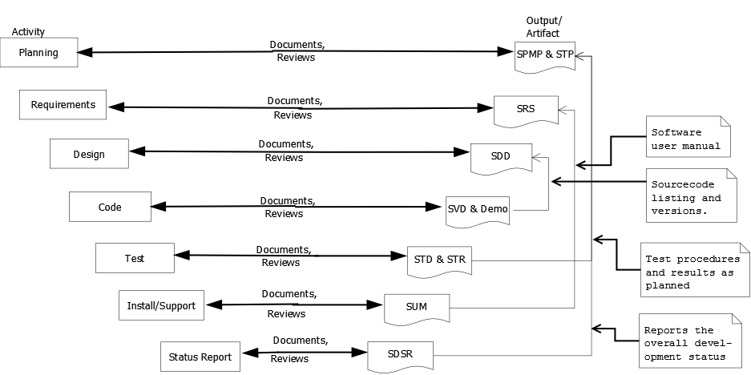

**Software Development Life Cycle**

Each incremental development spans through all activities from requirements, design, code, test, install/support, and status reporting, except the initial development spans from the planning activity. The purpose of the initial development is to produce the following the following software artifacts:

1. A complete project plans (=> SPMP & STP).

2. Requirements specification for the overall system framework => SRS).

3. Overall system architecture and high-level component designs (=> SDD).

4. Source codes for the system architecture and framework (=> SVD).

5. Test cases, procedures, and results for the framework (=> STD & STR).

6. A draft installation and user manual (=> SUM).

7. A draft development status report (=> SDSR).

In all other incremental developments, steps 2 through 7 are reiterated and correspondent documents are updated.

**2.2 ORGANIZATIONAL STRUCTURE**

The SPMP will identify the organizational entities external to the project and their interaction with the project team, as well as internal project structure and roles and responsibilities for the project.

**EXTERNAL STRUCTURE**

The visitors are the external entity to the organization, they can only see the basic information provided about DC.

* He can know about the aim, mission, and core areas of development center. In short, he can know what is DC all about, how it works and what are its objectives.
* The visitors have limited access to the web application and they can’t alter any content.
* He can see the profile of current and past DC members along with their achievements and           project experiences.
* Information about all the current and past projects are made available to the visitors.

**INTERNAL STRUCTURE**

The internal team structure with the team roles separated. The team structure is hierarchical. There is a team leader, and the rest of the roles are assigned to the other team members. All team members have their own area of responsibility and everyone is expected to contribute equally to the project.

The team will engage in regular weekly meetings. Additionally team members will communicate

by e-mail on as needed basis. Personal communication between team members is strongly encouraged.

**2.3 PROJECT ROLES AND RESPONSIBILITIES**

|  |  |
| --- | --- |
| **Roles** | **Responsibilities** |
| Team leader | -Motivate the team members to perform their tasks  -Help the team in allocating the tasks and resolving issues  -Creates and maintains MIS SRS |
| Development  manager | -Lead the team in producing the development strategy  -Lead the team in producing the preliminary size and time estimates for the products to be produced  -Lead the development of SRS  -Lead the team in producing the high level design  -Lead the team in producing the design specification  -Lead the team in implementing the product  -Lead the team in developing the build, in  tegration and system test plans  -Lead the team in developing the test materials and running the tests  -Lead the team in producing the product’s user documentation. |
| Planning manager | -Lead the team in producing the task plan for the next development cycle  -Lead the team in producing the schedule for the next development cycle  -Lead the team in producing the balanced team plan  -Track the team’s progress against the plan |
| Support Manager    Process Manager | -Lead the team in determining its support needs and in obtaining the needed tools and facilities  -Manage the configuration management system  -Maintain the project report  -Maintain the h/w and s/w requirements.  -Maintain the team’s issue and risk tracking system.    -Lead the team in producing and tracking the  equality plan.  -Alerts the team to quality problems.  -Lead the team in defining and documenting its processes and in maintaining the process improvement process.  -Establish and maintain the team’s development standards. |
| Technical Manager | -The team has access to a technical writer that will help the team produce better documents.  -.The technical writer and the team  mentors cannot be assigned any tasks other than document proofing and team mentoring. |

**2.3 ORGANIZATIONAL INTERFACES**

Team leaders during each phase will be responsible for coordinating team meetings, updates, communications, and team deliverables

**3. MANAGERIAL PROCESS:**

The SPMP will specify the project management processes for the project and will include:

the project start-up plan, risk management plan, project work plan, project control plan and project closeout plan. In order to be successful the team must deliver a software product that will satisfy the needs of the users.

**3.1 MANAGEMENT OBJECTIVES AND PRIORITIES**

In order to achieve its objectives the team has the following goals and priorities:

1. Use good software engineering methods to develop the product.

* Experience a new way of doing things.
* Practice reflective learning.

2. Deliver a quality product that meets the client expectation.

* Deliver a product that is stable and relatively defect-free.
* Deliver a system that addresses the client’s needs

3.Conduct ourselves as professionals.

* Value the time of team members, mentors, and the user.
* Accept and support team decisions.
* Communicate openly and frequently.
* Take responsibility for the success of the project.
* Be proactive

4.Make efficient use of the resources available to the DC.

* Learn from each other.
* Experiment with existing tools and processes.

**3.2 ASSUMPTIONS , DEPENDENCIES AND CONSTRAINTS**

* One assumption about the web application is that it will always be run on the system that have enough performance. Also to run the web application it is the most important to have an internet connection and Internet Server Capabilities..
* The user should provide valid information as the input that can be readily available to him/her. Also user might be having enough knowledge of the operating system and advanced browser to be used.

**3.3 RISK MANAGEMENT**

The SPMP shall specify:

Risk management plan for identifying, analyzing and prioritizing project risk factors. Procedures for contingency planning and the methods that will be used for tracking certain risk factors, changes in levels of the factors and responses to those changes. The  team will maintain the project’s risk factors and strategies for risk mitigation in a separate document.

Risks can be of any of the following type:

* + 1. Market risk
    2. Financial risk
    3. Technology risk
    4. People risk
    5. Structure/process risk

**3.4 MONITORING AND CONTROLLING MECHANISMS**

For each project meeting each team produces an agenda and the minutes of the meeting. The minutes have to contain explicitly the action items assigned during the meeting. The agenda and minutes are posted on team specific bulletin boards by the team leader.

Controlling Mechanism consists of :

1. Weekly project status meetings
2. Shared document repository

**3.5 STAFFING APPROACH**

The staff of DC MIS is not fixed .Despite the team leader and the team members who were appointed since the beginning ,any member belonging to IIPS DC can contribute to it as per the requirements.

**4.TECHNICAL PROCESS**

**4.1 Methods, tools and techniques**

The DC MIS will consider using object-oriented methodology. Also, use of software patterns is greatly encouraged.Our organization heartly believes in open source technology. DC team has not made a firm decision for using any development tools at this point. Once the decision about the development tools is made, the section will be updated accordingly. Additional tools that will be used are: Sublime text editor, Oracle 8i, modern web browsers like google chrome etc.

**4.2  Software Documentation**

The following activities result in a project deliverable: -

Project Planning: Software Project Management Plan (SPMP) -

Requirements Analysis: Requirements Analysis Document (SRS) -

Analysis Review: Analysis Review Slides -

System Design: System Design Document (SDD) -

Implementation and Unit Testing: Code -System Integration and

System Testing: Test Manual

**4.3 Project Support Functions**

All project support documents will be completed in applicable phases.It provides either directly or by reference, plans for the supporting functions for the software project. These functions may include, but are not limited to, configuration management, software quality assurance, and verification and validation. Plans for project support functions are developed to a level of detail consistent with the other sections of the SPMP. The nature and type of support functions required will vary from project to project. The absence of a software quality assurance, configuration management, or verification and validation plan, however, must be explicitly justified in project plans that do not include them.

**5. WORK PACKAGES, SCHEDULE, AND BUDGET**

**5.1 Work Packages**

The various work activities to be performed in the project are defined in the DC MIS application. The work activities are decomposed from project management task, support task, and

product features into low-level tasks that expose all project risk factors and allow accurate

estimate of resource requirements and schedule duration for each work activity.

**5.2 Resource Requirements**

**5.2.1 Requirements control plan**

The requirements for the DC MIS will be documented in the SRS. There are two aspects of the requirements control plan:

* Traceability- Traceability means that every artifact that is produced by this project should be traceable back to the requirements documents. Traceability will be addressed during the review meetings as well as design and code walkthroughs.
* Change control- Even though that we do not expect any major change in requirements, once the SRS is formally released all changes will be approved and documented using the guidelines established in the Configuration Management Plan.

**5.2.2 Quality control plan**

Software quality control has a significant role in all of the stages of this application. The main drivers for quality control are:

* Make sure that the projects artifacts meet certain quality criteria.
* Provide the ability to verify that the project satisfies the requirements.
* Be able to find and remove defects in the earlier stages of the project. The quality control plan for this organization shall be specified.